**High Level Requirements**

**User Interface -** This program will run strictly from the command prompt, in its early form. The UI is limited to simple prompts and file outputs

**Hardware -** The hardware the user uses is not a huge deal, though the faster their computer, the faster this algorithm will run. However, when training the model, a computer with a dedicated GPU and a powerful processor should be used, as it may run a long time otherwise.

**Monolithic Architecture -** This is not a very complex program, apart from the algorithm itself. Therefore, it should all be contained within a single program, and be able to run without any external dependencies.

**UML Diagram**

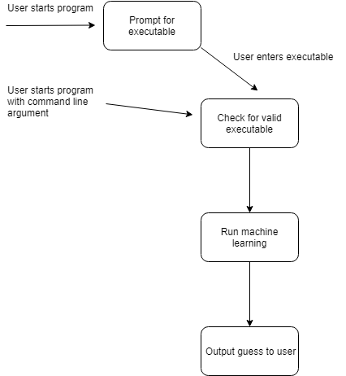

**Reports -** In addition to the prediction of the code being displayed to the terminal screen, the code will also be saved to a text file if requested by the user. If the user decides to train the model, a report will be generated at the end detailing the final results of the model and statistics about each training epoch.